***Condo Management System***

**RISK ASSESSMENT AND MANAGEMENT PLAN**

Version *1.0*

*04/02/2024*

**1 INTRODUCTION**

**1.1 PURPOSE OF RISK ASSESSMENT AND MANAGEMENT PLAN**

A risk is a potential problem that can occur. It can have harmful consequences on the project’s objectives in the future. Risk management is to identify and evaluate potential problems before they occur. The objective is to develop a plan to effectively address and mitigate risks.

The Risk Assessment and Management Plan (RMP) is an important document. It provides the team important information on possible problems. This helps the team to make informed decisions and prioritize tasks and risks during the project. The RMP will be monitored, documented and updated throughout the entire project lifecycle.

**2 RISK MANAGEMENT PROCEDURE**

**2.1 PROCESS**

All team members working on the project will be identifying, analyzing and managing risks throughout the project lifecycle. To reduce project delays and impacts, risks will be identified and accessed in the early stages of the project. To ensure that the documentation follows the RMP guidelines, one team member will be the Risk Manager.

**2.2 RISK IDENTIFICATION**

The risks were identified in the beginning of the project by assessing all team members’ experience and skills in software development. There was a meeting to discuss any skills that the team might lack for the project. This provided important technical and management risks associated with the project.

To identify, document and manage risks during the project, there are weekly team meetings to discuss and review each team member's progress on their assigned tasks to encourage team members to share any issues or challenges that they face because they could become risks. A risk analysis log file is accessible to all team members.

**2.3 RISK ANALYSIS**

The team is using qualification analysis and is reporting the level of risk in the Risk Reporting Matrix to prioritize what risks should be addressed and which can be ignored. All risks identified are analyzed in a risk analysis table that provides information on ranking, threats, vulnerabilities, contextual factors, risks, likelihood, impact, reduction of threats, reduction of vulnerabilities and level of residual risk.

**2.4 RISK RESPONSE PLANNING**

In the Risk Reporting Matrix, the risks will either be in the green, yellow or red zone. The risks can be addressed by avoiding, mitigating, accepting or transferring. Team members will be assigned to monitor risks falling in the red and yellow zone.

To mitigate risks, the team members will find solutions to prevent risk from happening and reduce its impact and probability. The solution will be proposed to the Risk Manager and the manager will be verifying the solution’s feasibility and will add and assign additional risk prevention tasks in the project schedule. This will minimize risk impacts.

**2.5 RISK MONITORING, CONTROLLING, AND REPORTING**

Important risks will be assigned to team members for monitoring, controlling and reporting during the project. The risk manager will be notified of project changes resulting from risk monitoring and controlling. Risks will be reported in the risk analysis table.

**3 TOOLS AND PRACTICES**

The risk analysis table serves as a log for risks for all team members. It will be maintained by the risk manager to ensure that it follows formatting guidelines. The Risk Reporting Matrix will be used for qualification analysis.

**4 RISK ANALYSIS AND MANAGEMENT**

**4.1 RISK ANALYSIS TABLE**

The risk analysis table helps to understand the severity of the risk by ranking them. The required information in the table are ranking, threats, vulnerabilities, contextual factors, risks, likelihood, impact, reduction of threats, reduction of vulnerabilities and level of residual risk. It helps the team to decide on how to address the risk.

The detailed risk analysis table is can be found in the file [Risk Analysis.xlsx](https://docs.google.com/spreadsheets/d/1mI_D5lBJim7m-mxVObdMf_5LxiT-qM4l/edit?usp=sharing&ouid=117308092083738229587&rtpof=true&sd=true). Examples of two risks related to the condo management system project are shown in Figure 1.

Figure 1: Examples of risks from Risk Analysis.xlsx file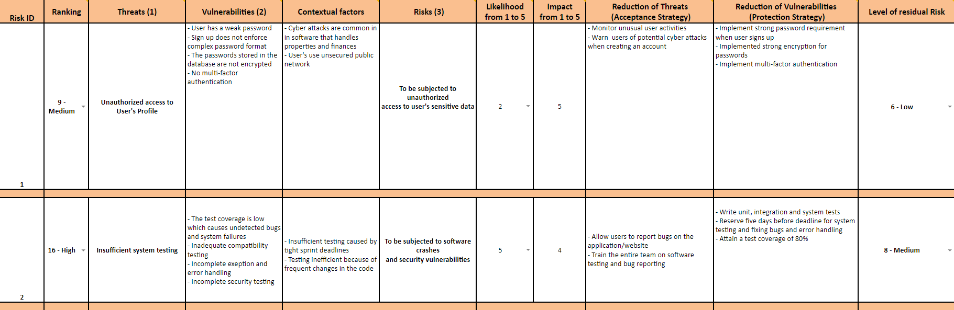

**4.2 RISK REPORTING MATRIX**

The risks identified in the risk analysis table are presented in the risk reporting matrix to visualize its severity. The list of identified risks shown in table 1 is a summary of the content of the risk analysis file. The risk reporting matrix is shown in figure 2. The risks are represented by their risk ID.

| Risk ID | Risk Type and Description | Risk Score | Resolved in Sprint | Strategy and Effectiveness |
| --- | --- | --- | --- | --- |
| **1** | **Security:**  Unauthorized access to user's profile | Medium | TBD | Mitigate |
| **2** | **Technical:**  Insufficient system testing | High | TBD | Mitigate |
| **3** | **Security:**  Data Breach | Medium | TBD | Accept |
| **4** | **Management:**  Poor communication within team | Medium | TBD | Mitigate |
| **5** | **Management:**  Unqualified teammates for mobile app development | High | TBD | Accept |
| **6** | **Requirements:**  Poor requirements definition | Medium | TBD | Mitigate |

Table 1: List of identified risks

| Likelihood | 5 |  |  |  |  | **5** |
| --- | --- | --- | --- | --- | --- | --- |
| 4 |  |  |  |  | **2** |
| 3 |  |  |  |  |  |
| 2 |  |  |  | **3,4,6** | **1** |
| 1 |  |  |  |  |  |
|  | 1 | 2 | 3 | 4 | 5 |
|  | Consequence | | | | | |

Figure 2: Risk Reporting Matrix